Meteo 3, Lab 4 Due: Friday, Sept 21, 12:20pm, 109 Walker Name___________________

4.15 The air’s water vapor content has a noticeable effect on human comfort. In recognition of this effect, meteorologists often report the apparent temperature, or heat index, defined as what the air temperature “feels like” to the average person if the effect of the moisture content of the air is taken into account. An empirical relationship linking air temperature and vapor pressure to the apparent temperature is:
ApparentTemperature=AirTemperature+(VaporPressure−16)
where the temperatures are in °F and the vapor pressure is in millibars (note that the units do not “match” here – this is simply a “shortcut” relationship that gives reasonable values of apparent temperature).

c. The table below gives an approximate vapor pressure (in mb) corresponding to several
values of the dew point (in ºF).

Dew Point (°F) | Vapor Pressure (mb)
60 | 20
70 | 25
75 | 29.6
80 | 33

Using this information, determine the apparent temperature (rounded to the nearest integer) for the following combinations of temperature (T) and dew point (T_{d}):

- T = 90°F, T_{d} = 75°F ii. T = 95°F, T_{d} = 70°F
apT =75+(29.6-16) =89°F apT =70+(25-16) =79°F

iii. T = 100°F, T_{d} = 70°F iv. T = 100°F, T_{d} = 60°F
apT = 70+(25-16) = 79°F apT =60(20-16) =64°F

4.16 Commonly in the Southern Plains during the spring, warm and dry air moving east from the desert Southwest or southern Rockies collides with warm and moist air moving northwestward from the Gulf of Mexico. The boundary where they meet is called a dry line (a dry line can be thought of, to some extent, as a dew-point front). Strong thunderstorms often form along the dry line, where the dew-point gradient can be very large.
- Give the formal names of the air masses that meet at a dry line.
Marinetime tropical
4.17 Topography plays a major role in lifting air and producing precipitation. In this question, we’ll explore that role in the state of Pennsylvania. You will need to access this topographic map of Pennsylvania to complete this question, as well as this map of Pennsylvania counties.
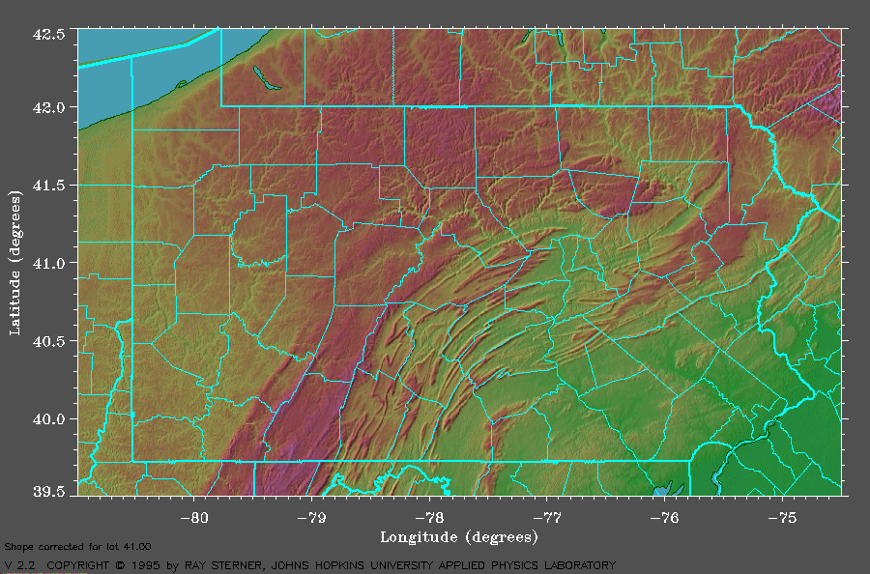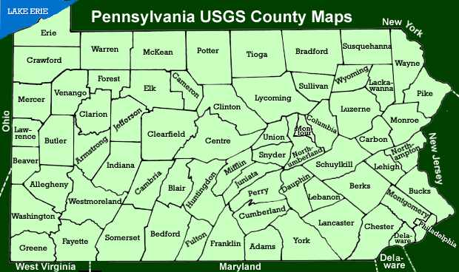
This chart, below shows average annual liquid precipitation (rain plus melted snow) across Pennsylvania. The prevailing winds across the state are westerly (though East Coast storms sometimes bring moist easterly winds, accounting for much of the precipitation in the eastern part of the state).
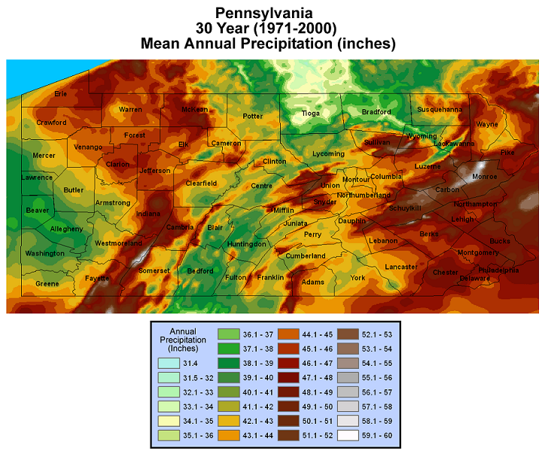
- With these wind characteristics in mind, consider the two prominent areas in Pennsylvania with precipitation maxima. For both of these areas, name three counties where the maxima occur.
South West region of Pennsylvania; (Fayette, Westmoreland and Somerset counties) and the East-Central region of Pennsylvania; (Carbon, Monroe and Schuylkill)

- Identify a zone (by naming at least six counties), stretching in a general north to south direction, that would be considered a rain shadow.
Tioga, Bradford, Wyoming, Huntingdon, Bedford and partly Clinton county.
4.20 You own a special soda can. There are cooling coils inside the can that allow you to vary the temperature of the soda. There’s also a special thermometer mounted on the side of the can that measures the temperature of the can. Explain how you could estimate the dew point of the air using this soda can.

When the soda can surface temperature reaches the dew point temperature, dew will form. This will evident when more water molecules will condense onto the surface than evaporate from the surface. Dew point will be noted when the first condensation occurs

4.26 As a way of communicating to the public the meaning of the dew point, a colleague of ours is fond of saying that “an increase of 20ºF in the dew point of the air means that the amount of water vapor in the air doubles.”
- Using the diagram below that links equilibrium vapor pressure to temperature, and a straight edge or ruler, determine how well this rule works. Estimate how much the equilibrium vapor pressure changes from 0ºF to 20ºF, from 20ºF to 40ºF, 40ºF to 60ºF, and from 60ºF to 80ºF so you can make conclusions about whether the rule works better for certain dew-point ranges than others.
Estimations:
0ºF to 20ºF = 3mb
20ºF to 40ºF= 10mb
40ºF to 60ºF= 20mb
60ºF to 80ºF= 35mb
From the estimates above the rule of “an increase of 20ºF in the dew point of the air means that the amount of water vapor in the air doubles.” Works best on ranges between 20ºF to 60ºF.

- One of the highest dew points ever measured was 95°F at Dhahran, Saudi Arabia at 3 P.M. local time on July 8, 2003. In units of millibars, what was the vapor pressure at that time? What if the dew point had “only” been 75ºF at that time (still, a very sultry value)? How well does the doubling rule mentioned in part (a) work at these extremely high dew points?

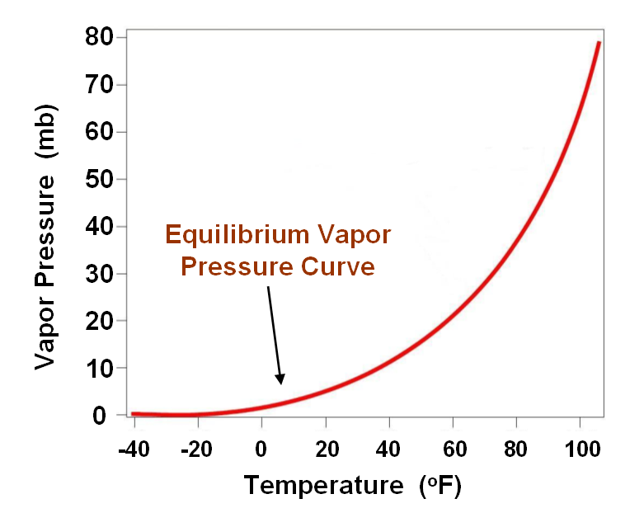

Vapor pressure at 95°F (Dhahran) is approximately 50mb.
Vapor pressure at 75°F (Dhahran) is approximately 30mb.
The doubling rule is less accurate as vapor pressure goes above 60°F, this solidifies the estimations in part (a).

5.7 You are given a high-resolution visible satellite image, below, over the Southern Plains at 1415 UTC on March 5, 2015. You are also given an animation of visible satellite images on that day from 1415 to 2245 UTC. You will need to view the animation online.
- On the 1415 UTC visible image, focus your attention on the whitish area that covers much of northern Texas and extends into Oklahoma. Offer evidence that this whitish area is snow cover. Again, the original online picture may be clearer.
The snow area according to Google maps is supposed to look cloudy with curvy edges along the slopes. This is visible on the south west part of texas.

- View the animation. What happens to the whitish area during the daytime hours on March 5? Based on the time of year, offer an explanation for the “evolution” of this whitish area on the visible satellite loop between 1415 and 2245 UTC.
During the day time, visibility is definitely clearer. Depending on the time of the year, the intensity of the whitish varies in summer and winter. The whitish area evolves by pilling up from spring, summer (March- May) towards the autumn and cold winter (June to February), and fading out reversely; from winter to hot summer.

- Note that these images are from March. Would this “evolution” have likely been as dramatic on a day in late January? Briefly explain (your explanation should mention the position of the sun in the sky).
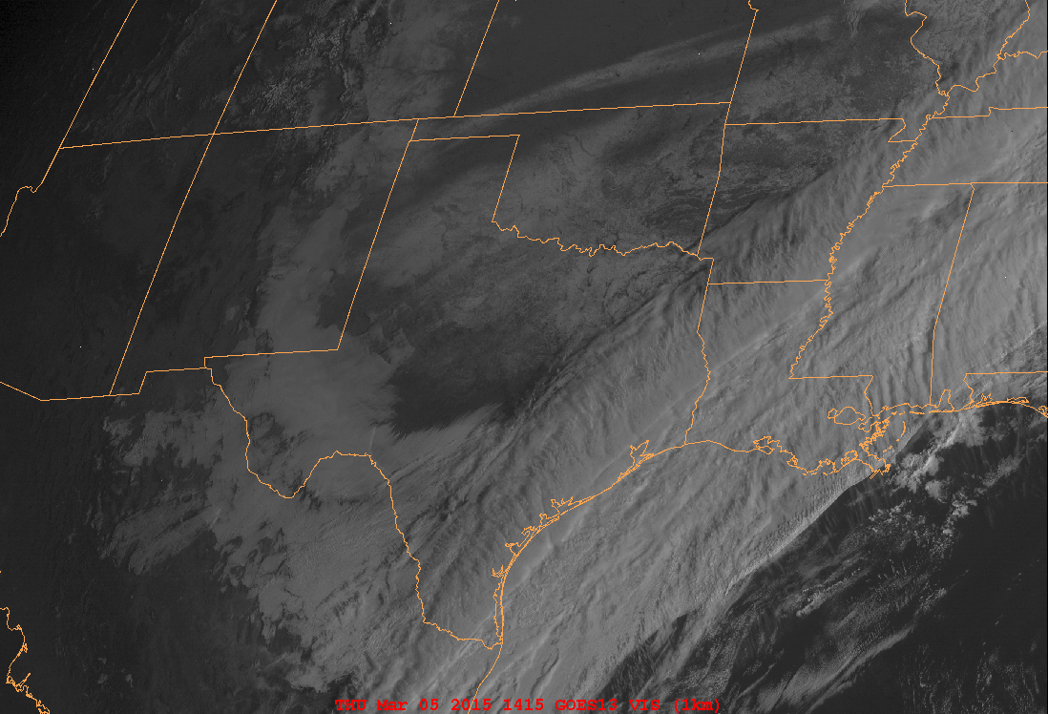

During March, this marks the beginning of spring, the snow coverage is less compared to the snow coverage at the end of January where winter is at climax.

5.21 On August 13, 2014, historic flash flooding occurred on Long Island, setting an official New York State 24-hour precipitation record at Islip, NY, with 13.57" of rain.

Consider this animation of radar reflectivity (left,below- only the first image in the loop, view online) from 2:00 to 9:00 A.M. local time and this image of radar-derived precipitation estimates (right, below), essentially the storm total as of 8:30 A.M. local time (1230 UTC) – note that nearly all of the rain fell prior to 8:00 A.M. local time (12 UTC) that day, so the radar-derived precipitation image captures nearly all of the rain.

- Based on the radar-estimated precipitation, what was the maximum amount of rain that fell on Long Island? Does this radar estimate agree with the surface measurement from Islip, NY? Based on the radar loop, explain what factors led to so much rain falling in the area where the maximum rainfall occurred was.
Maximum rain that fell on the long island = 13.57
The radar estimate agrees with the surface measurement from Islip since their it varies slightly from Lowa State University (13.25 in the one minute) and lightly different than NWS records, which show 13.21" from 12 am Local Standard Time (LST) to 11 am LST.
Factors that could probably led much of rainfall falling in Islip is the Deep, tropical moisture available from Wallops island (2.38’’) and that of Upton (1.81’’).

- Notice on the radar-derived precipitation image, there’s a radial extending from the radar site (KOKX) to the northwest that is devoid of radar data (if you look really close, you can even see two such radials, and there’s even evidence of this data-devoid cone on the animation of radar reflectivity). Can you make an educated guess about what could possibly be blocking the radar beam along these radials?
TIP: Type “National Weather Service forecast Office Upton NY” into Google Maps and switch to the satellite view. If you zoom in, you should see the radar dome, then pan around and see what else you can find near the radar that might be blocking the radar beam.

Terrain or the Solar Station.

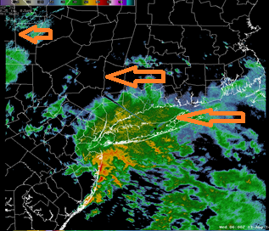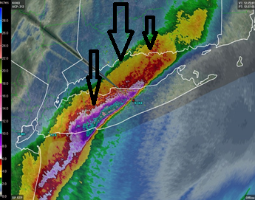
6.2 Consider these two charts below (Map 1 and Map 2) which show idealized patterns of isobars (labeled in mb).
- On each pattern, draw a dozen or so streamlines (arrows) to show how the wind would blow if the earth did not rotate. Assume that these isobar patterns are in the Northern Hemisphere. Explain the reasoning behind your streamlines.
In map 2, the theory here is based on Coriolis effect, the winds would move from straight from north to south and, while in map 1 the direction would move east to west due to the air pressure caused by hot regions and cold regions. Although the directions on map 1 depends on the position of the sun.

- Would your answer be different if these pressure patterns were in the Southern Hemisphere? Again, offer a brief explanation.
No. The earth being stagnant will have winds move in a specific direction, at constant speed.

MAP 1
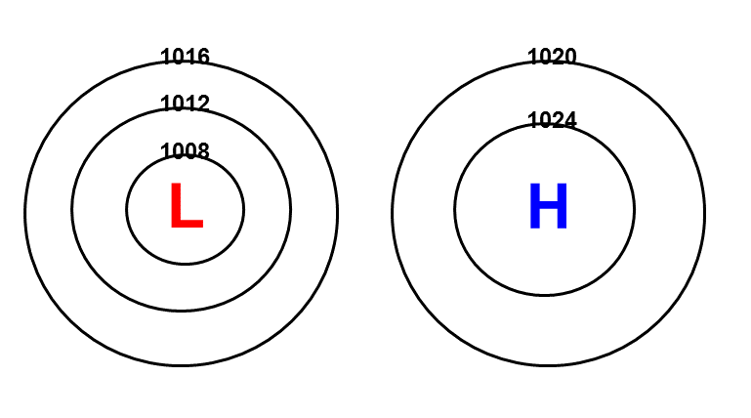
MAP 2
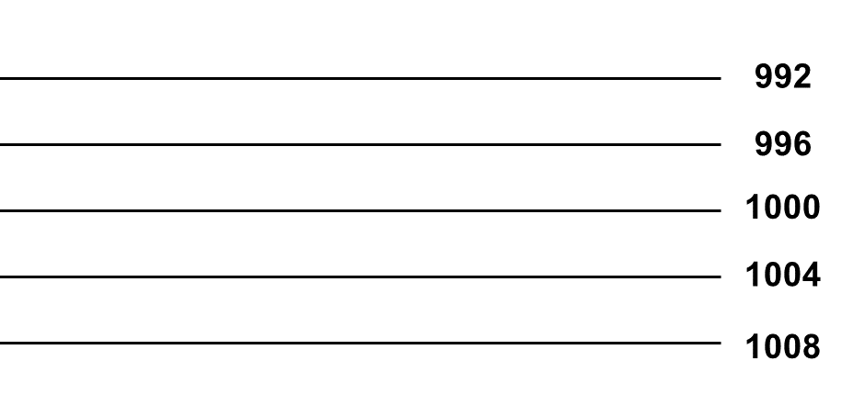
6.7 Consider this forecast surface weather map from the National Weather Service. The grey lines are isobars, drawn every 4 mb. Five points labeled A, B, C, D and E are shown. Each point is on an isobar, so it is easy to determine the sea-level pressure at each point. The table below gives the elevation (in meters) of each point that is not at sea level:
B: 25 m below sea level (this is Death Valley)
C: 1600 m (Denver, approximately)
D: 180 m (note that the Great Lakes are NOT at sea level)
E: 370 m (near State College)

In practice, converting from station pressure to sea-level pressure takes work and requires estimation of the average temperature of the “imaginary” column of air. Here, we will use a simple rule, that pressure decreases at 10 mb per 100 m in the lower troposphere.

- Using this rule, compute the station pressure at Points A, B, C, D and E (that is, the actual pressure at the locations). Round your station pressures to the nearest tenth of a millibar.

- Describe where the highs and lows of pressure would be on a map of the contiguous United States if station pressure was plotted instead of sea-level pressure.
Highs would be in B and A
Lows would be D and E
C would be neutral (Plainsboro)

